1. Launching Ec2 user   
Adding New User Techie – adduser space Username

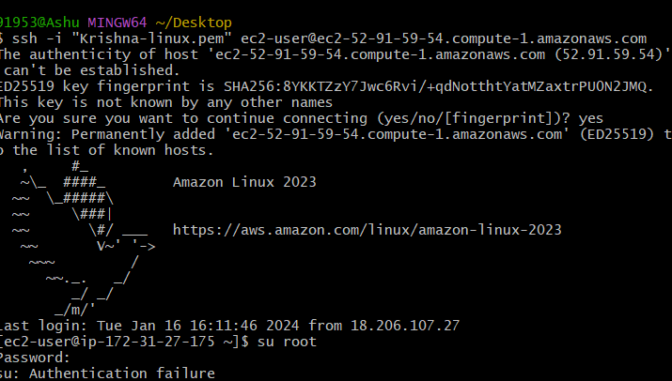1.Launching Ec2 user Adding New User Techie

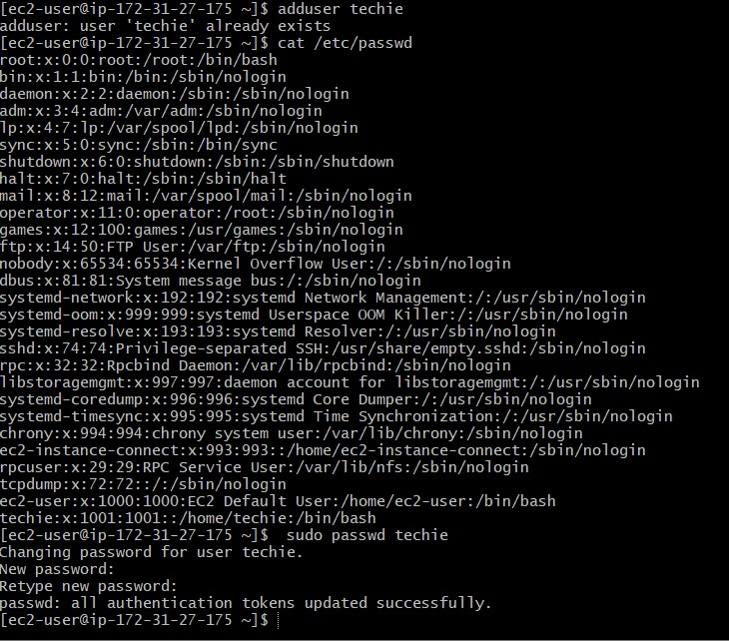

2.creating a password for techie- sudo passwd techie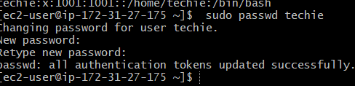

3.Give sudo access to Techie

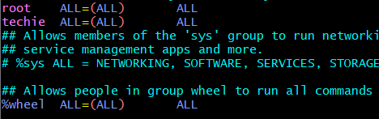

3.sudo access to techie